**Magnetism Summary**

**Magnets** have two **poles**: North (N) and South (S)

Magnets **attract** (opposite poles) and **repel** (same poles) other magnets

N – S and S – N attract N – N and S – S repel

Magnets attract **magnetic materials** (iron, steel, cobalt, nickel)

**Magnetism** (**magnetic force**) is a **non-contact force**, this means that it can act at a distance and can pass through some materials.

The magnetic force becomes weaker the farther away you are from the magnet.

The magnetic force is strongest at the poles.

Magnetic materials can be **magnetised** to make **temporary magnets** by slowing stroking a magnets pole against a magnetic material in the same direction many times.

The **magnetic field** is the area where a magnet exerts a magnetic force.

The closer together the magnetic field lines, the stronger the magnetic force.

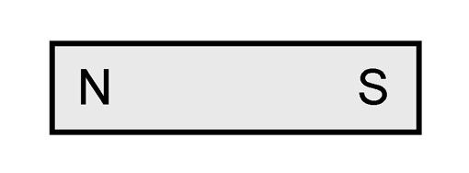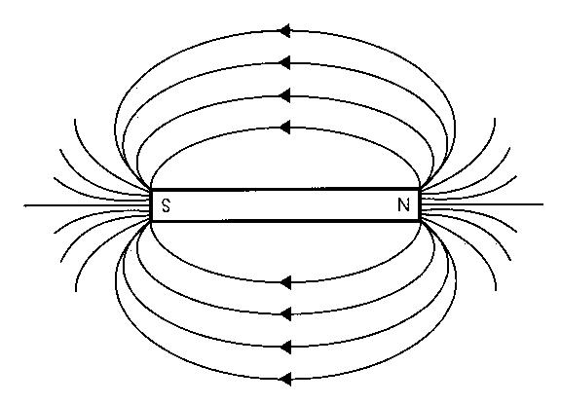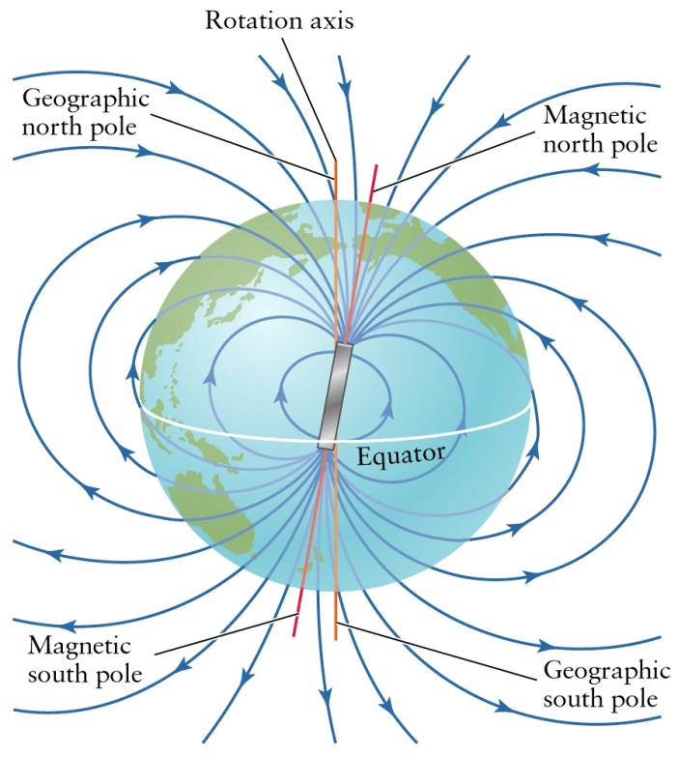

The Earth has a magnetic field.

A **compass** is an instrument that has a tiny magnet inside that always points North.

The shape of the Earth’s magnetic field is the same as if there was a giant bar magnet inside the Earth with the S pole pointing geographic North. This is why the N pole of the **compass** points to geographic North.

**Electromagnets** are magnets that are made by passing electric current through a coil of wire.

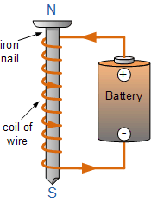

Electromagnets create a magnetic field but only when the electricity is switched on (electric current is flowing).

The strength of an electromagnet can be increased in the following ways:

* Increasing the number of coils in the wire
* Increasing the electric current (increasing the voltage)
* Using a magnetic material for the core